Little SPARK: Simple Play Adaptations to Reference for Kids

Giant Emotions Stamp Set
Description: | Image:
The stamp set includes ten 3" rubber stamps with comfort grip handles. The see-thru top of the stamps provide ease in placement. | 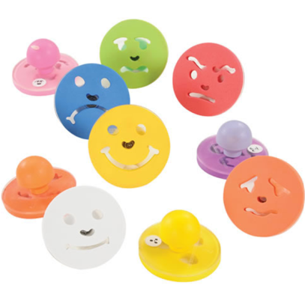

Who Might Benefit?
Those who have difficulty identifying feelings, need support determining what to do when they have certain feelings, or have motor challenges and are unable to draw picture to depict feelings.

Why Use?
Provides an opportunity to talk about feelings, show how they are feeling without talking, and engage in art activities which may include a discussion of emotions.
Instructions for Use: | Adaptation Ideas:
Environmental Considerations  - Quiet, private area for discussion of feelings.  Positioning & Alternate Positioning  - Use in any position; seated, standing, on the floor, with a slanted surface, vertical plane or any solid, flat surface.  Basic Play/Use  - Provide ink or paint, paper and stamps and allow children to create then talk about it.  Extended Play/Use  - Create feelings puppets with stamp on cardstock, incorporate in story time and music time (e.g. “If you’re happy and you know it”).  Play/Use with Others  - Take attendance by letting children choose their stamp based on how they feel and stamp a chart. | Simplify It  - Reduce number of emotions/stamps.  Stabilize It  - Create loop or cuff around stamp handle for easier grasping.  Add Sensory Cues  - Add textures to the handles of the stamps.  Alternative Uses  - Use stamps and index cards or emotion pictures/cards to create a Feelings Match game.  - Make a giant feelings wheel on foam board and add a dial for children to indicate their feelings.

Words to Encourage Play/Use
I feel  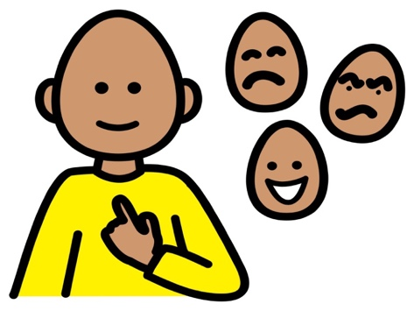 | Happy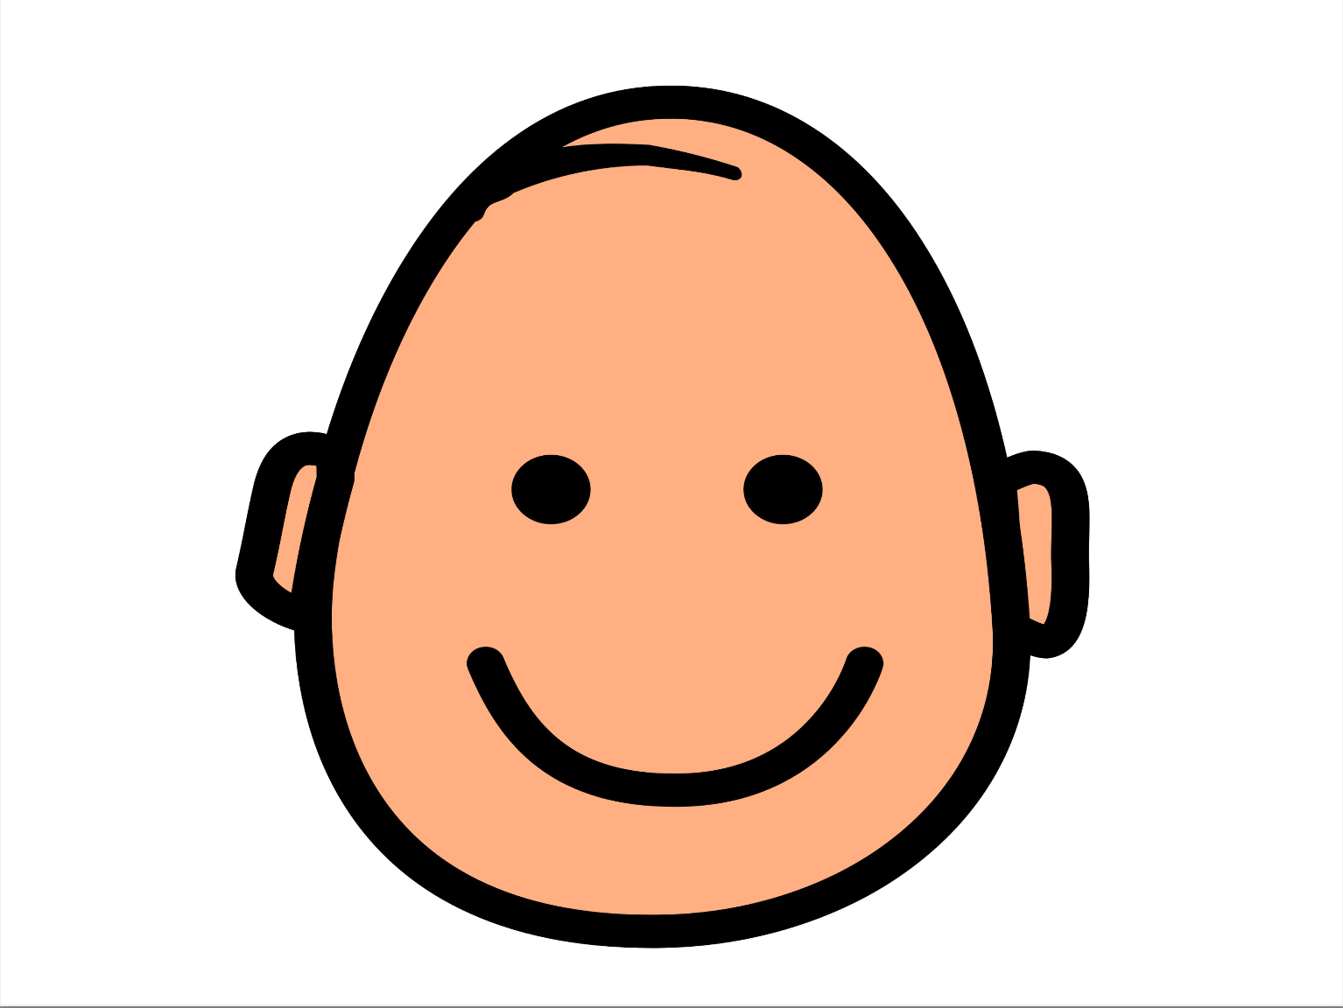 | Sad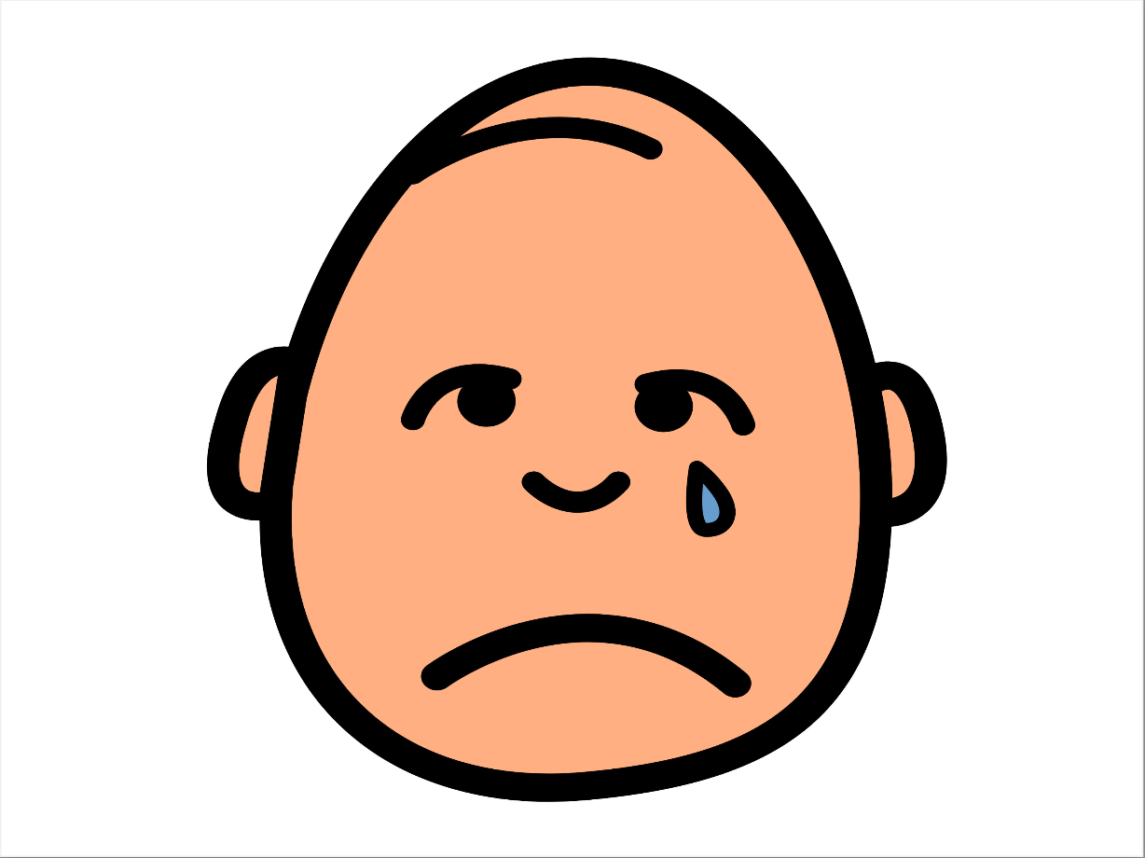
Sick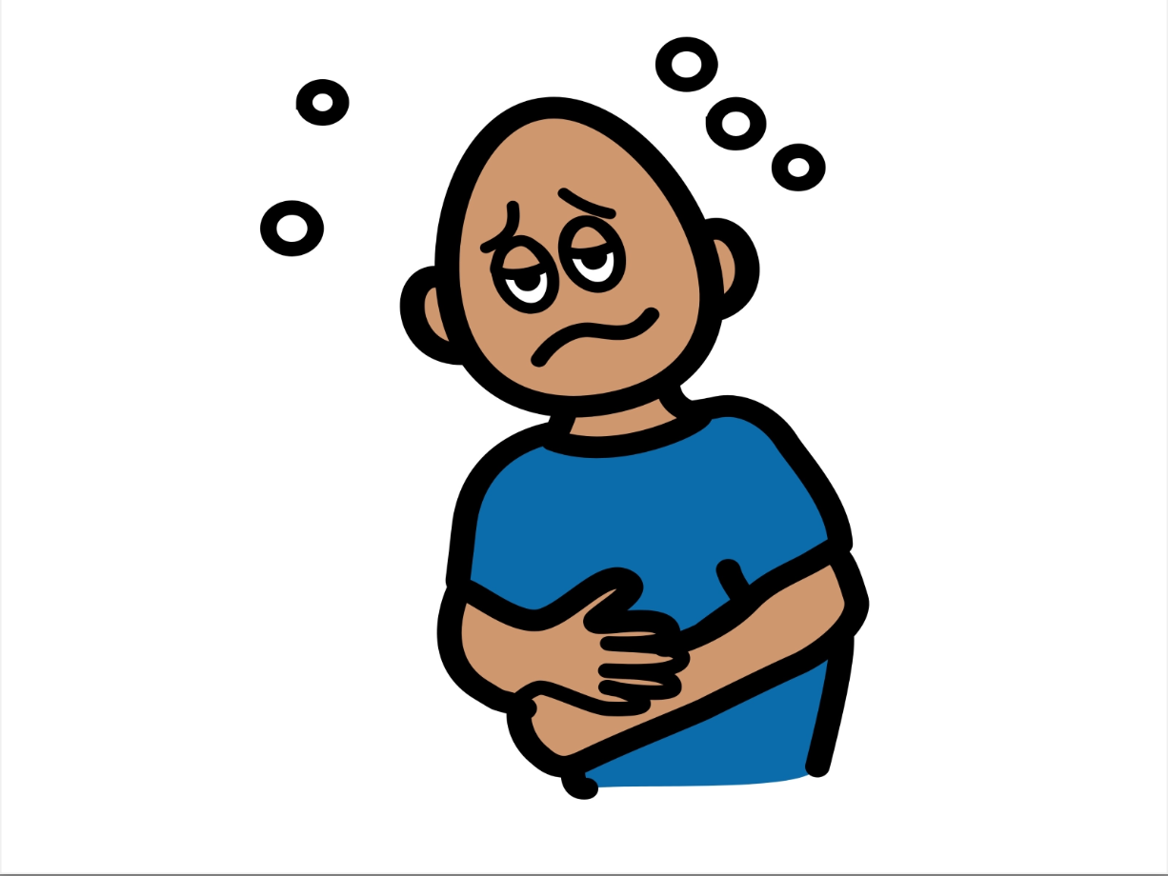 | Surprised | Tired 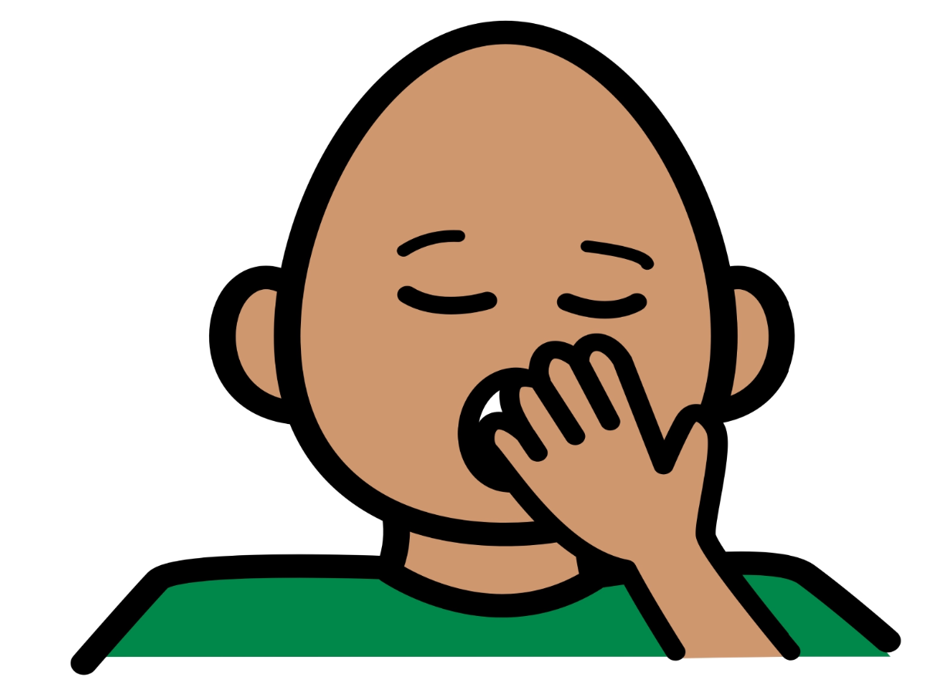
Confused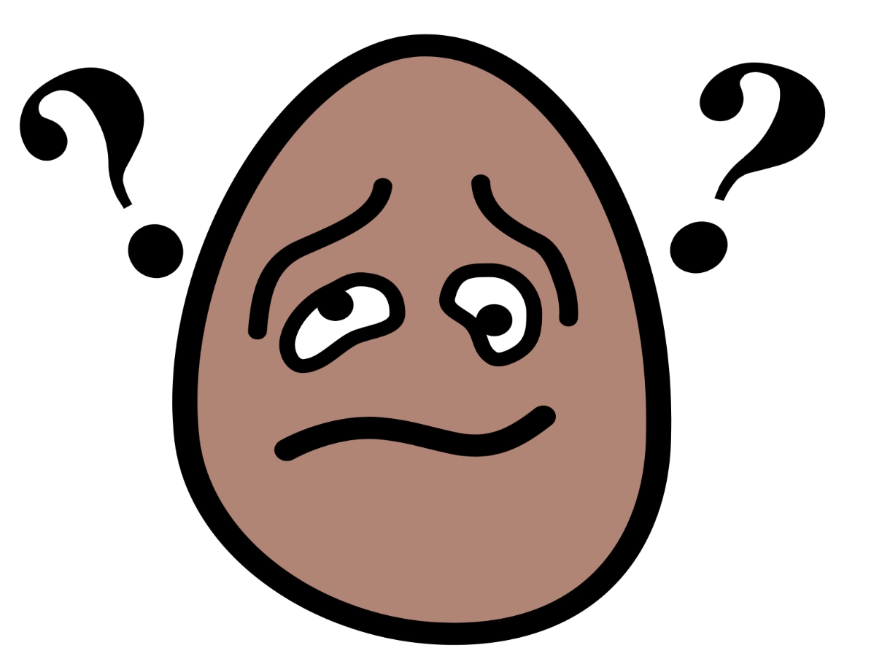 | Mad | Scared  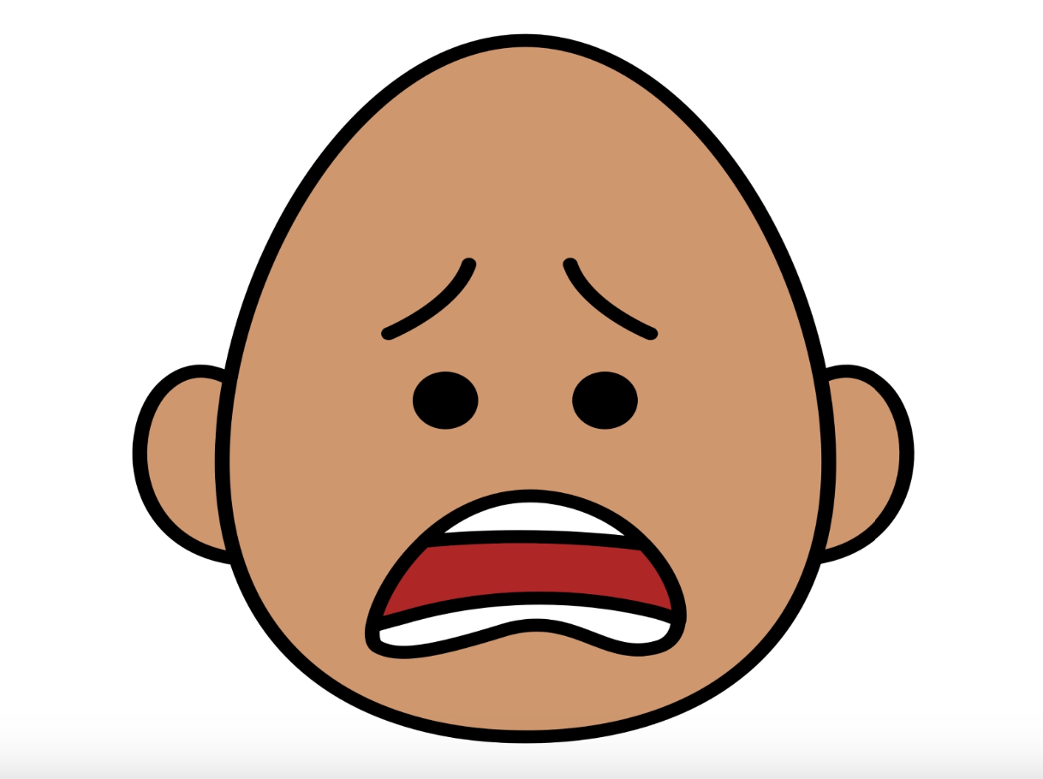
*”Adaptations” adapted from: Haugen’s Modes for Adapting Toys based on materials from the "Let's Play" Project at the University of Buffalo
PCS is a trademark of Tobii Dynavox, LLC. All rights reserved. Used with permission.

